**Assignment 6.5**

**Write a Mapreduce code to find out number of males and females survived in the titanic tragedy and save the output in sequence file output format.**

**Sample input:**

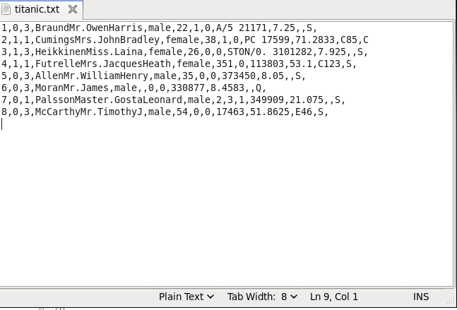

**Driver class:**

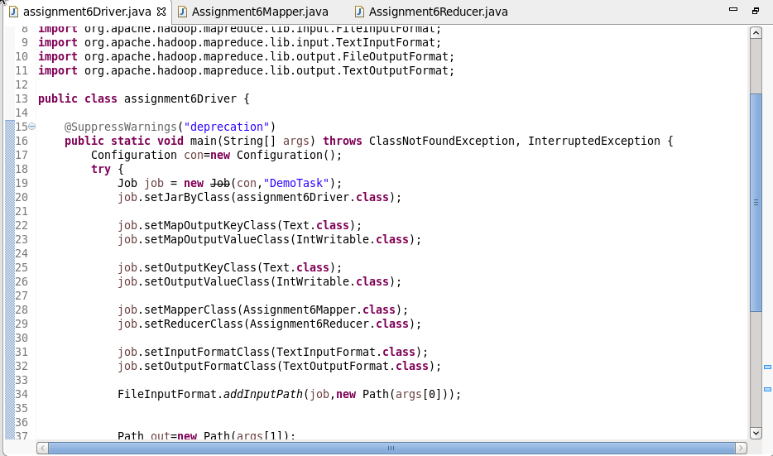

**Mapper class:**

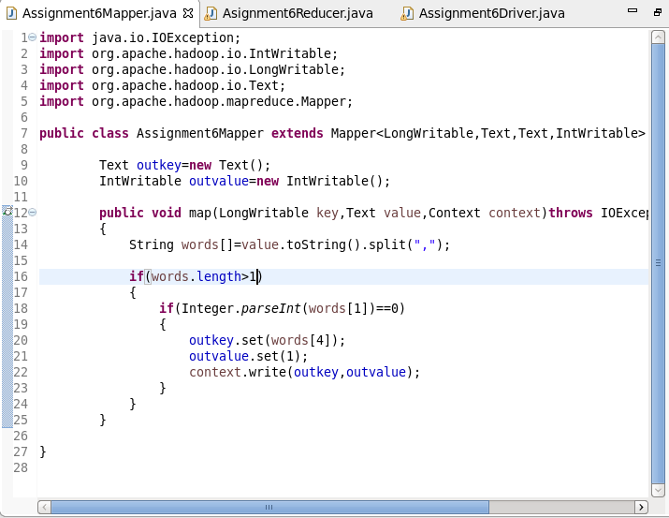

**Reducer class:**

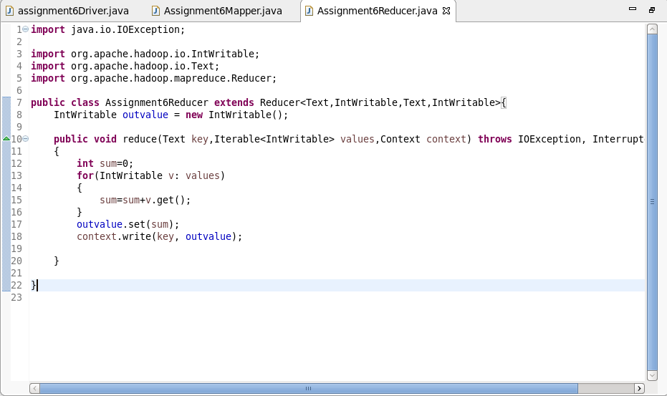

**Output:**

